**4. Registered Users**

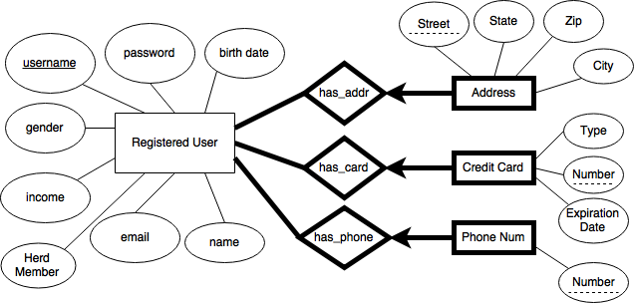

CREATE TABLE Registered_Users

(

Name CHAR(30) NOT NULL,

Email CHAR(50) NOT NULL,

Herd_Member BIT,

Income INTEGER,

Gender CHAR(6),

Username CHAR(20) NOT NULL,

Password CHAR (20) NOT NULL,

Date_of_Birth DATE,

UNIQUE (email, username),

PRIMARY KEY (username)

);

CREATE TABLE User_Address

(

Username CHAR(20) NOT NULL,

Street TEXT NOT NULL,

State CHAR(20) NOT NULL,

ZIP_Code INTEGER NOT NULL,

City CHAR(20),

PRIMARY KEY (Username),

FOREIGN KEY (Username) REFERENCES Registered_Users (Username)

ON DELETE CASCADE

);

CREATE TABLE Credit_Card

(

Username CHAR(20) NOT NULL,

Type CHAR(20) NOT NULL,

Number INTEGER NOT NULL,

Expiration_Date DATE NOT NULL,

UNIQUE (number),

PRIMARY KEY (Username),

FOREIGN KEY (Username) REFERENCES Registered_Users (Username)

ON DELETE CASCADE

);

CREATE TABLE Phone_Number

(

Username CHAR(20) NOT NULL,

Phone_Number INTEGER,

PRIMARY KEY (Username),

FOREIGN KEY (Username) REFERENCES Registered_Users (Username)

ON DELETE CASCADE

);

Registered Users Table

|  |  |  |  |  |  |  |  |
| --- | --- | --- | --- | --- | --- | --- | --- |
| Username | Name | Email | Herd_Member | Income | Gender | Password | Date_of_Birth |

Address Table

|  |  |  |  |  |
| --- | --- | --- | --- | --- |
| Username | Street | State | ZIP_Code | City |

Credit Card Table

|  |  |  |  |
| --- | --- | --- | --- |
| Username | Type | Number | Expiration_Date |

Phone Number Table

|  |  |
| --- | --- |
| Username | Number |

**9. Bidding**



CREATE TABLE Bidding

(

Username CHAR(20),

Amount INTEGER,

Time TIMESTAMP,

PRIMARY KEY (Username)

FOREIGN KEY (Username) REFERENCES Registered_Users (Username)

ON DELETE CASCADE

);